
Proposal to implement new organizational strategies for the shippensburg university marching band
A Recommendation Report

May 2, 2025
Emily Boyer
Shippensburg University

Proposal to Implement New Organizational Strategies for the Shippensburg University Marching Band

Prepared for: Dr. Carla Kungl
ENGL-238 Professor
Shippensburg University

Prepared by: Emily Boyer
ENGL-238 Student
Shippensburg University

May 2, 2025

Abstract

On March 27, 2025, Dr. Carla Kungl approved a proposal for a research project to find improvements for the organization of the Shippensburg University Marching Band. This recommendation report covers new organizational strategies that the SUMB should implement. Marching bands require a strict organizational setup to ensure the success of members and the overall group. I conducted primary and secondary research on rehearsal techniques, student leadership, and design elements, which are all organizational aspects of a marching band. Based on my research, I learned proper rehearsal techniques to improve performances, ways to select student leadership, and how to choose certain design elements for uniformity and sound. With this research, I concluded that these organizational aspects are necessary to ensure each member is satisfied with their time in marching band. I then proposed three recommendations: a more selective process for student leadership, newer rehearsal techniques, and an adherence to design elements.

Table of Contents
Abstract iii
Table of Figures iv
1.0 Introduction 1
2.0 Research Methods 2
2.1 Primary Research 2
2.1.1 “Efficient Teaching in Marching Band Rehearsals” by Christopher Hoch 2
2.1.2 “Student Leaders, Extra Help on the Marching Field” by Daniel Kiene 2
2.2 Secondary Research 3
3.0 Results 3
3.1 Primary Research Results 3
3.1.1 “Efficient Teaching in Marching Band Rehearsals” by Christopoher Hoch 3
3.1.2 “Student Leaders, Extra Help on the Marching Field” By David Kiene 4
3.2 Secondary Research Results 5
3.2.1 Elements of Design 5
3.2.2 Best Practices in Operating a Non-Profit Marching Arts Organization 7
3.2.3 The Importance of Feedback 7
4.0 Conclusions 8
5.0 Recommendations 9
6.0 References 10

Table of Figures
Figure 1 Preferred instrumentation within a marching band 5
Figure 2 Flow chart for hierarchy within a marching band 7

1.0 Introduction

This report aims to discuss my findings and recommendations for the Shippensburg University Marching Band. The goal is to recommend new organizational strategies to improve member satisfaction.

Marching bands are musical ensembles that incorporate visual and musical arts into one performance (Owen). These ensembles range from middle school groups to professional groups (such as bands involved in Drum Corps International (DCI)), and these ensembles also incorporate a differing range of instrumentation. Bands who are members of DCI do not utilize woodwind instruments, which include saxophones, clarinets, and flutes. Some colleges and universities, such as The Ohio State University, also use a similar instrumentation.

At Shippensburg University, the Shippensburg University Marching Band (also known as the SUMB) features both brass and woodwind instruments along with a drumline and front ensemble (a section that features stationary mallet equipment and other percussive instruments). The SUMB prides itself on being the “centerpiece for school spirit and pride,” but this outwardly positive image does not accurately reflect the inner workings of the marching band. That is not to say the marching band is falling apart, but certain organizational aspects prevent many members from having an enjoyable experience.

Several factors play a role in the success of a marching band. From the organization of leadership within the band to proper rehearsal strategies and appropriate leadership roles, each detail must work together to produce a successful season. For the SUMB, each of these factors tends to fall short compared to the expectations put into place at the beginning of each season. These flaws tend to leave members feeling stressed or uncomfortable in intense situations.

While my experience in the SUMB has only spanned two years, it was within these two years that I saw the weaknesses related to the organization of the band. During my research, I learned of other methods pertaining to organization within marching bands that the SUMB could incorporate to provide a more enjoyable and worthwhile experience for its members. Using these methods could also help improve the band’s success throughout the season. Based on these methods, my recommendations include: a more selective process for student leadership, newer rehearsal techniques, and an adherence to design elements.

2.0 Research Methods

To thoroughly research organizational methods, I utilized both primary and secondary research. For my primary research, I found two blog posts written by band directors who shared their strategies and experiences that have helped provide desirable outcomes for student members. For my secondary research, I found three academic articles and papers that discuss proper organizational methods for marching bands. These articles provided me with information about how to select leadership properly within the band and how to run smooth rehearsals.

2.1 Primary Research

Because I could not do an interview, I used blog posts because they are still first-person accounts about my topic. After reviewing the blog posts, I found that many band directors have used a trial-and-error method when trying new organizational methods within their bands. The first article I found was written by the band director for Richmond Hill High School in Richmond Hill, GA (Kiene). The second article was written by the band director for The Ohio State University in Columbus, OH (Hoch). These blogs provided information regarding proper rehearsal techniques and methods for selecting student leadership.

2.1.1 “Efficient Teaching in Marching Band Rehearsals” by Christopher Hoch

Christopher Hoch is the current band director for The Ohio State University. He has served as their band director since 2015 and has worked with Rutherford B. Hayes High School in Delaware, OH, for seven years. His experience with different bands allowed him to try new methods in rehearsals to see what works efficiently.

2.1.2 “Student Leaders, Extra Help on the Marching Field” by Daniel Kiene

Daniel Kiene is the current band director for Richmond Hill High School in Richmond Hill, GA. He received music degrees from Armstrong Atlantic State University, Georgia Southern University, and the Shenandoah Conservatory of Music. His expertise has helped his band win several marching band competitions.

2.2 Secondary Research

I conducted my secondary research using online articles and academic papers. I found three articles that help offer insights into organizational methods for both on and off the marching field.

3.0 Results

My results consist of the information found within my primary and secondary research. I conducted research on academic articles and blogs written by current band directors. I will start by discussing the results of my primary research. After, I will discuss the results of my secondary research.

3.1 Primary Research Results

Conducting research using blogs provided me with first-person information regarding rehearsal techniques and student leadership selection.

3.1.1 “Efficient Teaching in Marching Band Rehearsals” by Christopoher Hoch

Hoch explains that the first step in organizing a marching band is having good planning methods, whether that be for sudden changes in weather or when organizing the show (Hoch). Being able to plan ahead of time allows for quick communication when a problem occurs, allowing for smooth transitions.

With regard to rehearsal techniques, Hoch explains that there are three fundamental skills that a band director needs in order to provide the most helpful information for student members. The first skill is to be a “recording engineer.” What he means by this is to frequently record music rehearsals to aid in constructive feedback. This method allows directors to apply feedback to a run-through of music so students can analyze their own mistakes and what they need to improve on. At Ohio State University, Hoch states that new recordings are filmed almost every rehearsal, which also aids students in music memorization and rehearsal preparation.
The second skill band directors need is to be a “film producer.” With recording music, recording marching visuals is also necessary. From basic warmup blocks to show run-throughs, recording the visual aspect allows directors and section leaders to help show members the mistakes they have made and how they can improve. At Ohio State University, a new recording is made with either a phone or tablet during each rehearsal, as well.

The third skill band directors need is transparency. Communication is one of the most critical factors in running a marching band, especially when there are over a hundred members in a single band. Quick and efficient communication ensures that every member is on the same page so that the goals set for a particular day can be accomplished smoothly and on time. If communication is unclear, members will be hesitant to follow directions if multiple students state different information.

3.1.2 “Student Leaders, Extra Help on the Marching Field” By David Kiene

Kiene discusses the importance of student leaders on the marching field because it allows band directors to have multiple eyes and ears on all members simultaneously (Kiene). Several leadership options exist, from section leaders/drum majors to crew heads and cabinet positions. Crews typically consist of the librarian crew (they cover music), the quartermaster crew (they cover uniforms), and the instrument crew (they cover broken instruments. The cabinet positions consist of president, vice president, treasurer, and secretary.

For section leaders, Kiene explains that these students have the best instrumental techniques. Essentially, these members are band directors for their own sections to ensure that each member plays the correct notes and rhythms.

For drum majors, these are the top student leaders within a band. They are in charge of understanding both music and drill and working alongside band directors/section leaders to ensure smooth rehearsals. These student leaders should be selected through an audition process and interview.

Kiene also discusses the proper selection process for selecting student leaders. For his students, he requires an application, an interview, and an audition. For the interview, the band asks the students questions to determine their qualifications for the position. For the audition process, he requires students to teach new music to the band during a rehearsal while he observes. Kiene also has them teach marching to the band to ensure they can go over each performance component related to marching band.

3.2 Secondary Research Results

With my secondary research, I will discuss my findings about information regarding organizational methods for marching bands.

3.2.1 Elements of Design

There are four major elements of design for marching bands that focus on the organization of musical and visual aspects (Bailey):

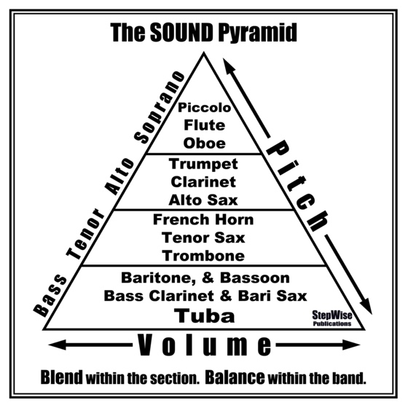
Instrumentation:

Instrumentation refers to the number and type of instruments that are used within a musical ensemble. For marching bands, there are several different types of instrumentation, but the main type of instrumentations used is the symphonic style, which includes both woodwinds and brass instruments. For bands that include woodwinds, they tend to lean towards piccolos rather than flutes due to the fact that the rest of the band usually drowns them out.
Figure 1 Preferred instrumentation within a marching band. "The Sound Pyramid." The Mechanics of Music, Mechanics of Music, 10 Nov. 2017, sites.psu.edu/themechanicsofmusic/2017/11/10/29/

The symphonic style for organization involves placing woodwind instruments in the front with brass behind them to create a more full and well-rounded sound. This style also prefers a larger number of brass/lower-voiced instruments compared to woodwinds (see figure 1 for the preferred instrumentation).

Intervals and Spacing:

Intervals and spacing refer to the distance set up between each member for visual purposes. This element of design is most important for parades to create a visually appealing organization. If all members are cramped together, it prevents them from moving forward at a standard pace.
Distinctive Movements:

Distinctive movements refer to the method of marching regarding the legs. Some bands prefer a “knee-high” style of marching in which members lift their knees while moving, with the high point being where the thigh is parallel to the ground.

Other bands prefer a “straight-leg” style, which involves a stiff knee movement that creates the effect of a toy soldier-like movement.

Another important distinctive movement is the playing and carrying positions of the band. The carrying position refers to the position in which members are not playing their instrument. They are holding it in front of them instead. Each of these movements must be thoroughly explained to members to ensure uniformity for visual appeal. For example, having flutes that are held parallel to the ground creates a clean look from the audience’s perspective.

Music:

Music refers to the selection and style of music that is being performed. The most important factor in selecting music is choosing pieces that are easy enough for the ensemble to play well. Simplicity ensures that good musical quality is present. It is better to play easier pieces and sound great than to play harder pieces and sound mediocre.

Another factor is the style of music and the way it is composed. Having a variety in key, style, meter, and tempo produces an exciting show that keeps the audience interested in the performance.

3.2.2 Best Practices in Operating a Non-Profit Marching Arts Organization

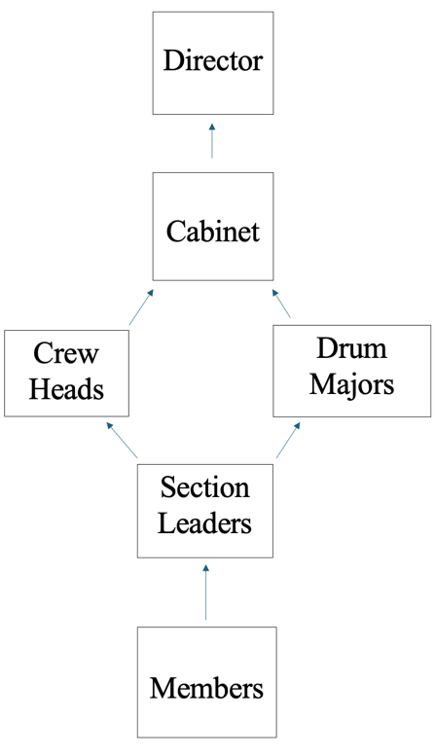
This academic paper was written by Anthony J. Snapp for his master’s thesis at Drexel University. In this paper, Snapp discusses the importance of keeping the right leaders in the right positions. Inadequate leadership results in weaknesses, which work against the success of a marching band and the satisfaction of its members (Snapp).

One of the most common problems found in member leadership positions is that there are members who desire to give back to the band that has played an impactful role in their lives without having the proper skills or qualities that are needed for these positions. Student leaders should consistently behave as role models while also delivering positive results in the proper manner.

Another necessary factor that should be put into place is the hierarchy of staff and student leadership that allows for the proper flow of information among the band. It is difficult for band directors when students arrive with minor issues, creating a stressful situation while the band director is already working on other matters. If a minor issue needs to be resolved, it is better for students to first talk with their section leaders before the problem is moved up the chain of command (see figure 2 for an example of the hierarchy within a marching band).
Figure 2 Flow chart for hierarchy within a marching band. Note: This figure was created by the author.

3.2.3 The Importance of Feedback

One of the most important aspects of a marching rehearsal is good feedback. Many band directors opt for traditional phrases such as “Great job!” or “That needs some work!” These phrases, however, do not provide adequate feedback that allows students to understand what they did right and what they did wrong (Silvey).

An essential aspect of feedback is explaining not only what the problem is but how to fix it. By providing feedback that highlights a problem and offering ways to change it, students are able to focus on the mistakes they made in a previous run and apply the corrections as they move forward. Pointing out an issue does not leave students guessing what they did wrong.

Another essential part of good feedback is providing constructive criticism rather than using strong negative language that might deter students from thinking they can improve. Constructing the negative feedback in a positive way leaves students wanting to work harder to improve in both their music and marching.

4.0 Conclusions

Based on the primary and secondary research I have conducted, I have concluded that there are three significant factors that play a role in the organization of a marching band: student leadership, proper rehearsal techniques, and elements of design.

My research has provided me with the conclusion that without properly following these guidelines, a marching band’s success tends to falter, leaving students unsatisfied with both their performances and their time spent in the band.

Student leadership is a necessary part of a marching band to help the band run smoothly without solely relying on a single band director. However, proper auditions and selection processes must be put into place to ensure these members are helping their sections and the entire band in the right manner. If the right students are not chosen, then rehearsals may become more difficult when an issue arises and they cannot fix it.

Proper rehearsal techniques are needed to help guide students towards making progress and for efficiency. Without good feedback and materials to analyze for performance purposes, students are left wondering what areas they need to improve and what skills need to be reworked.

From my secondary research, I conclude that design elements play a large role in the success of a marching band’s season. Without strict organization within these areas, students might not live up to the expectations that a band director sets into place at the beginning of the season.

5.0 Recommendations

Based on my conclusions, I have established three recommendations:

- Student leadership must follow a stricter selection process.
- New rehearsal techniques must be put into place.
- Design elements must be adhered to more closely.

The first recommendation of a stricter selection process would ensure that the right people (those who are qualified) are given leadership positions such as section leaders and drum majors. I propose that auditions consisting of teaching both music and marching to sections must be required to highlight whether a member meets the requirements needed for these roles. Failure to do so in the past has resulted in section leaders who are unable to help their sections improve with their show music and basic marching fundamentals.

The second recommendation of new rehearsal techniques would ensure that members are receiving the right feedback and information to help them learn from their mistakes and grow as a band. I propose that every show run the band performs during rehearsals should be recorded and submitted for the band to review at the end of every rehearsal. With the recording, a list of areas that need improvement should also be submitted. Band directors and student leadership should also work on giving proper feedback that highlights a problem and ways to fix it. Failure to do so in the past has resulted in confusion among members about what they did wrong.

The third recommendation of adhering to design elements would ensure that the band is producing a quality sound. I propose that the music abilities of members should be taken into consideration when selecting music. This would allow members to focus on the quality of sound rather than struggling to keep up with the music. I also propose reworking parade blocks to create a uniform structure that is visually appealing to the audience.

6.0 References

Bailey, George L. The Organization and Administration of the Marching Band. 1960. Eastern Illinois U, MA thesis.
Hoch, Christopher. "Efficient Teaching in Marching Band Rehearsals." The Instrumentalist, June 2020, theinstrumentalist.com/june-2020/efficient-teaching-in-marching-band-rehearsals/#:~:text=Starting%20each%20repetition%20with%20four,individual%20sections%20on%20the%20field. Accessed 14 Apr. 2025.
Kiene, Daniel. "Student Leaders, Extra Help on the Marching Field." The Instrumentalist, Oct. 2010, theinstrumentalist.com/october-2010/student-leaders-extra-help-on-the-marching-field/#:~:text=They%20are%20responsible%20for%20teaching,show%20themselves%20to%20be%20dependable. Accessed 14 Apr. 2025.
Owen, Melissa-Jo. "Marching Band." EBSCO, 2023, www.ebsco.com/research-starters/music/marching-band. Accessed 29 Apr. 2025.
Silvey, Brian A. "Strategies for Improving Rehearsal Technique: Using Research Findings to Promote Better Rehearsals." Sage Journals, vol. 32, no. 2, May 2014.
Snapp, Anthony J. Best Practices in Operating a Non-profit Marching Arts Organization. 2019. Drexel U, MA thesis.

